TRACK NAME: SOFTWARE AUTOMATION TESTING

PROJECT NAME: AMAZON (ONLY FOR ENGG)

TEAM LEADER: Pachimala Sruthi

TEAM MEMBER: Uddisa Kusuma Lakshmi Priya

TEAM MEMBER: Umar farukh

Software Testing Automation

Manual Testing

**AMAZON (ONLY FOR ENGG)**

Amazon is an American multinational technology company focusing on e-commerce, cloud computing, online advertising, digital streaming, and artificial intelligence web site for searching a product and order as per end user wish list. It has been often referred to as "one of the most influential economic and cultural forces in the world, and is often regarded as one of the world's most valuable brands. It is considered one of the Big Five   American technology companies, alongside Alphabet (parent_company_of Google), Apple, Meta (formerly Facebook, Inc.) and Microsoft. Amazon also distributes a variety of downloadable and streaming content through its Amazon Prime Video, Amazon Music, Twitch, and Audible units.  
**Amazon Dashboard:**

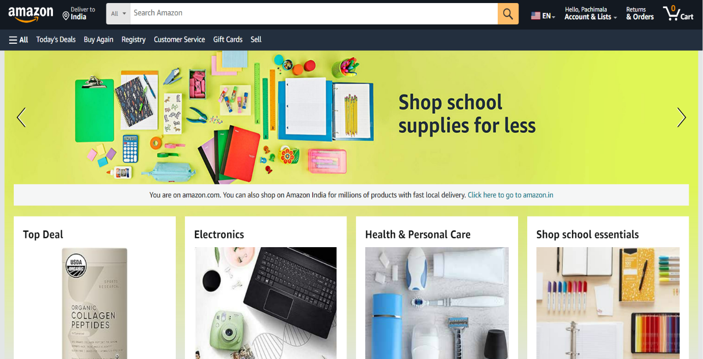

Link: <https://www.amazon.com/>

**Project flow:**

* User interact with the UI to enter into system
* Enter your login credentials then Login inputs are analyzed and verified as per the baseline document.
* Once the Login credentials are validated, the user will enter the amazon home page and the end user can select an item from the category and input a search item and click on the magnifier button.

To accomplish this, we have to complete the activities listed below:

* Define problem/problem understanding

Specify the business problem

Business Requirements

Literature survey

Social or Business impact

* Test Case Preparation

Understanding Requirements

Convert test steps to script

* Script Test Case Execution

Data -Driven Testing

* Handling And Validating Buttons

Handling And Validating Input Buttons

Handling And Validating Dropdown Buttons

* Test Listeners

Setup And Tear Down

Creating Test Listeners For Registration Validation

* Integration Of Katalon+ Git+ Jenkins

Integration Of Katalon Studio With Git And Git hub

Git Integration

Integration With Jenkins

Integration With Katalon Git, Git hub And Jenkins

* Cross -Browser Testing Using Test Cloud
* Report Generation And Sending Report

**Define problem/Problem understanding:**

specify the business problem:

specify the business problem means Providing flexible and prominent services to end users to search an item to make an order as per their wish list.

A business problem can be defined as any hurdle, situation or variation that leads to a difference between the desired objectives and accomplished results.

Some problems present themselves (machine failure), while other require in-depth analysis of the organization (declining or slow growth).

Business Requirements:

An Amazon project can have a variety of business requirements, depending on the specific goals and objectives of the project. Some potential requirements may include:

* Accurate and up-to-date information about products: The project should use the most recent and reliable data about product as per end user interest/wish list, in order to ensure that the information is accurate and relevant to end user needs.
* Flexibility: The Amazon system should be flexible and able to adapt to end users' needs.
* Compliance: The project should comply with all relevant laws and regulations.
* User-friendly interface: The Amazon system should be easy to use and understand for ordering different items and store their wish list for later order.

Literature Survey:

A literature survey for an Amazon project would involve researching and reviewing existing studies, articles, and other publications on the topic of drug classification. The survey would aim to gather information on current scheduling/appointment systems, their strengths and weaknesses, and any gaps in knowledge that the project could address. The literature survey would also look at the methods and techniques used in previous drug classification projects, and any relevant data or findings that could inform the design and implementation of the current project.

Social Or Business Impact:

**Social Impact:** Improved end user Interface: By providing accurate and up-to-date information on the latest product as per end user search history. Amazon project can help end user to make more informed decisions about selecting the products, leading to improved end user interface.

**Business Impact:** By providing information about availability of latest products in different ways, an Amazon project can assist end user by new notifications as per end user search history.

**Test Case Preparation:**

Software testing depends heavily on test data. It is the most crucial aspect to understand requirements and collect test data for the requirements if the requirements do not exist.

Understanding Requriements:

**Activity1: Prepare test Scenarios**

**Test Scenario 1.1:**

First Validate the amazon application to search an item in amazon dashboard to search any product or any item.

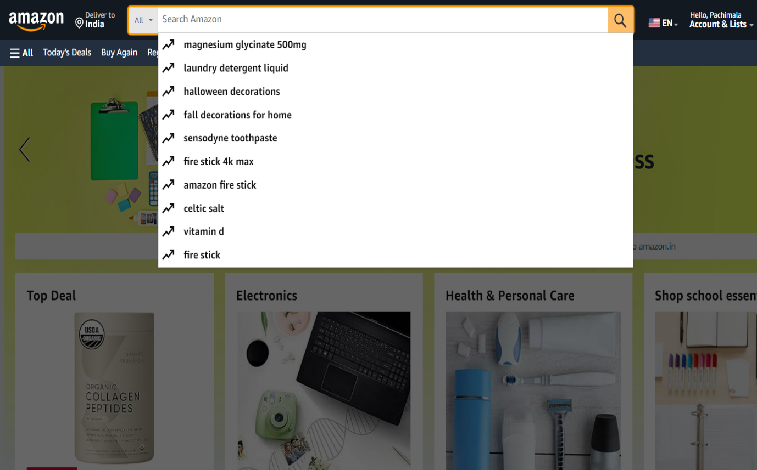

**Test Scenario 1.2:**

Next validate the amazon application for registering as a new user. First we have to create the account of amazon for new user.

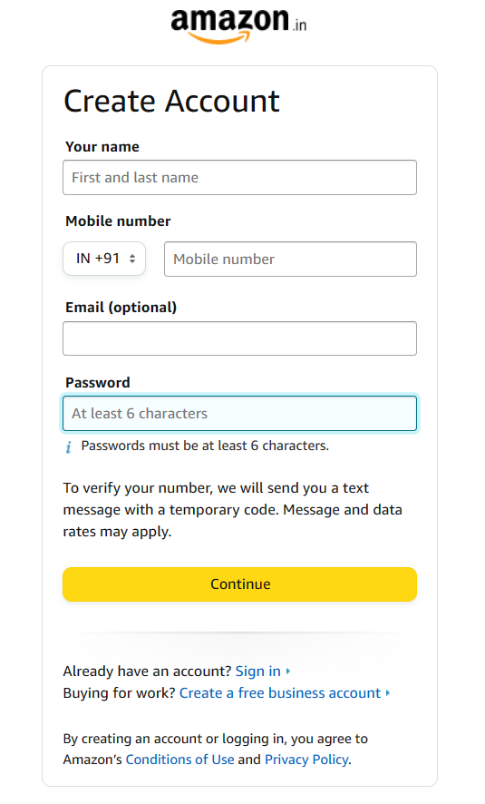

**Test Scenario 1.3:**

Validate the amazon application for the footer links. Footer link means most commonly, websites use internal links in the footer to include links to

high priority pages like services pages, product categories, and company info.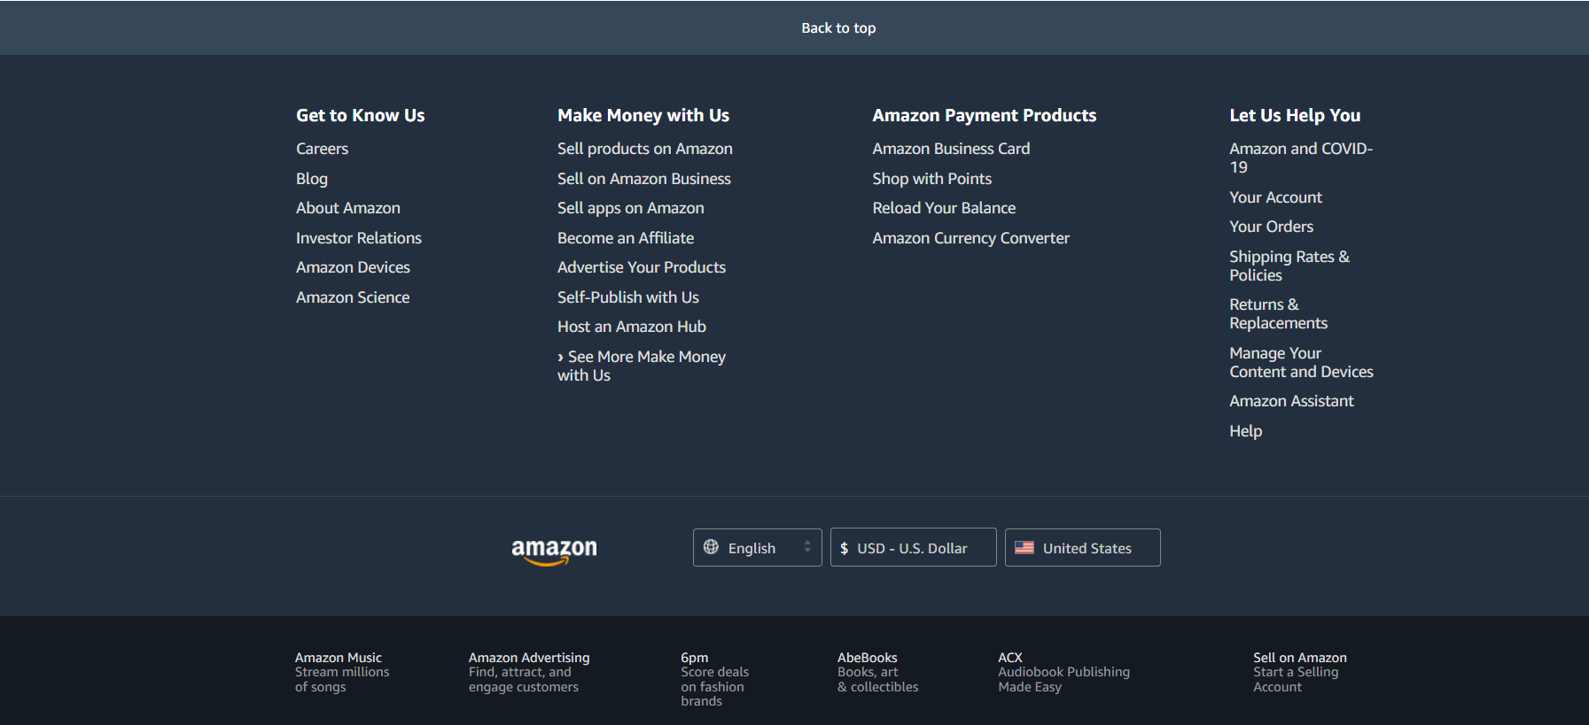



**Test Scenario 1.4:**

Validating the amazon application for the list of countries in the footer page.

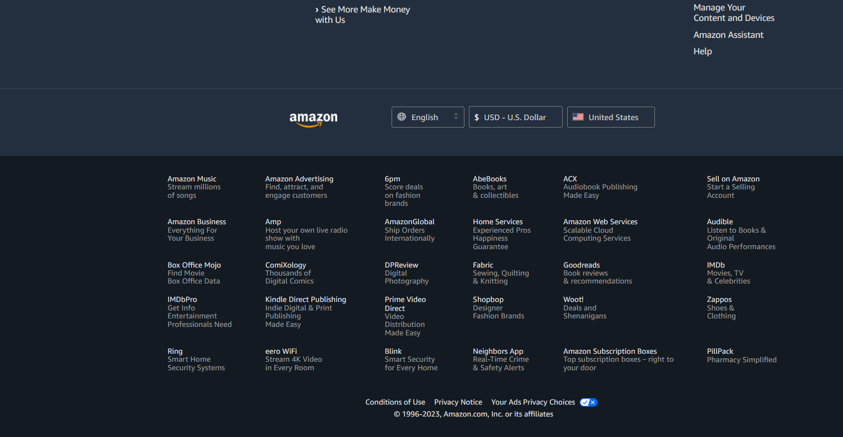



**Test Scenario 1.5:**

Validating the amazon application for total number of hyper links present on the web page. In the amazon dashboard there are number of hyper link address.

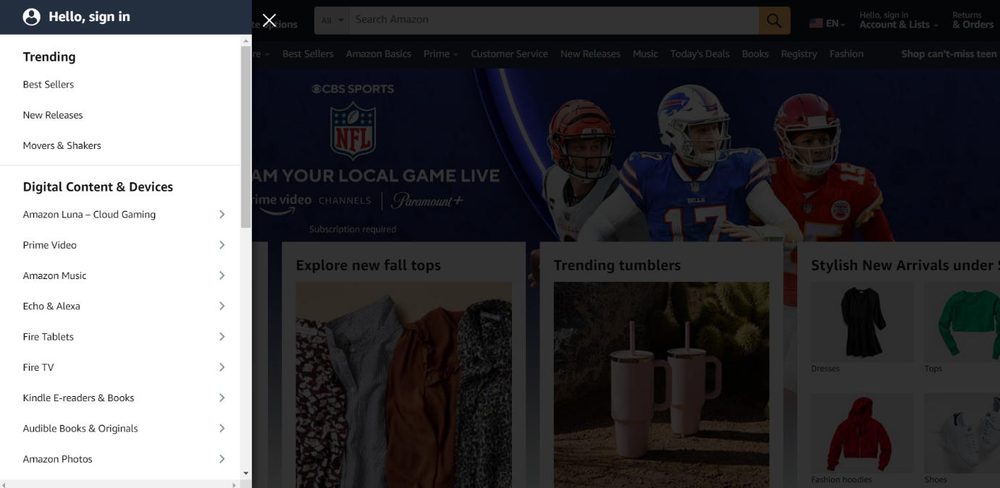



**Test Scenario1.6:**

Validating the logo present in the home page. In amazon it is representing the logo for any website it contains the individual logo.

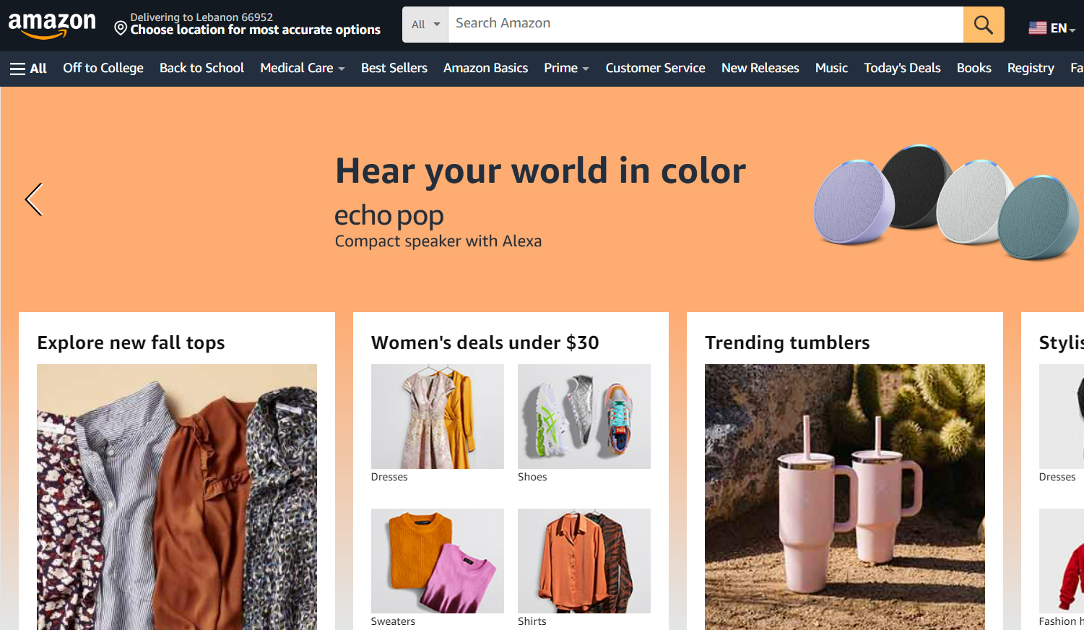



**Activity 1.2:  Test case Development**

**Test Case:**

First Validate the Facebook Application Login. Browser should be launched. First open the URL(<https://www.facebook.com/login.php>)

Enter the username as per the user.

Next Enter the password.

Click on the button.

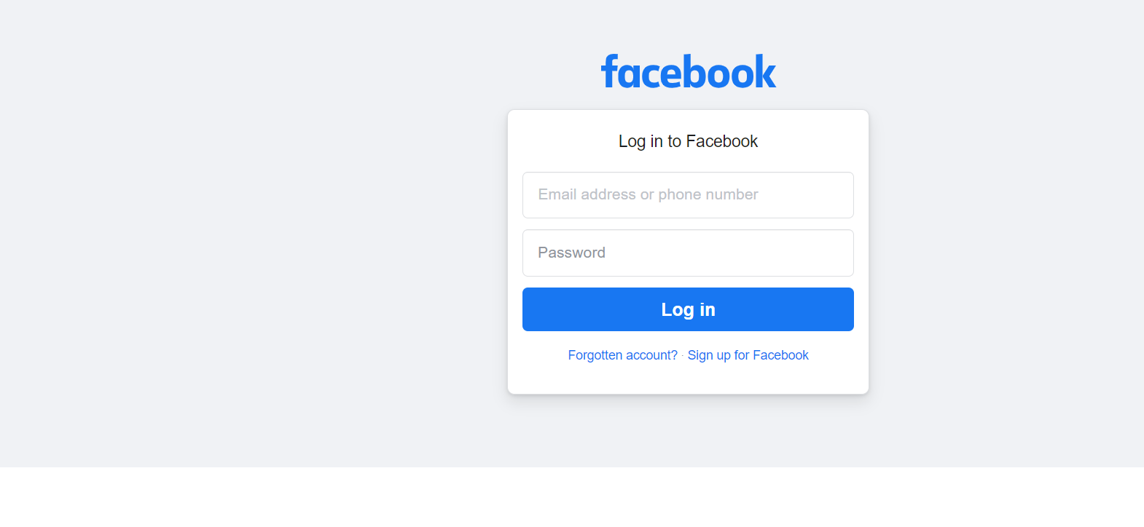

**Activity 1.3:  Validation Table**

During the preparation of the test case, some functionalities populated with more inputs.

Suppose example Login, for login baseline documents have the specifications  for username and password will be like

Example:

**Username Specifications:**

1. Minimum 4 characters and Maximum 15 characters
2. Start with alphabet
3. Should not start with special characters
4. First letter is alphabet followed by special characters
5. Username consists of at least one capital letter

**Password Specifications:**

1. Minimum 6 character and maximum 20 characters
2. Start with alphabet
3. Should not start with special characters
4. First letter is alphabet followed by special characters
5. password consists of at least one capital letter
6. Password consists of at least of special character.

**Test Case:**

We can select any type of items in amazon website. Like books, electronic, mobile phones, home appliances, washing machines, furniture, wooden tables, clothes, etc.

**Example 1:**

I have searched in books category I have selected and items related to Davinci code should be displayed.

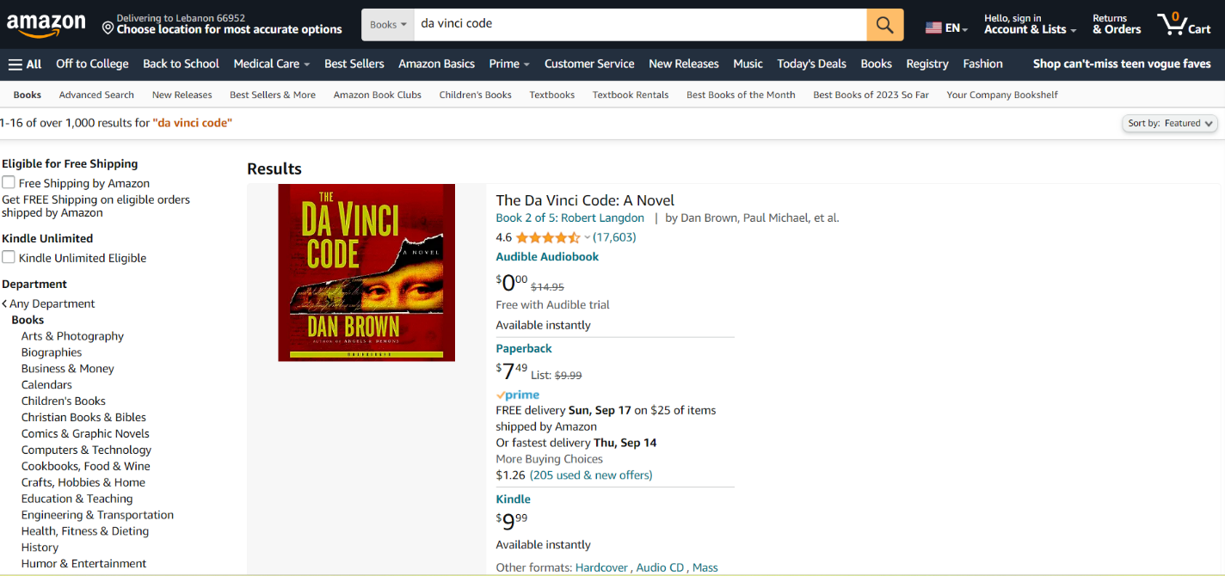

Link: <https://www.amazon.com/s?k=da+vinci+code&i=stripbooks&crid=K65XBDEMJ966&sprefix=davan%2Cstripbooks%2C465&ref=nb_sb_ss_sc_1_5>

**Example2:**

I have searched in electronic category. I have selected the items related to mobile phone should be displayed.

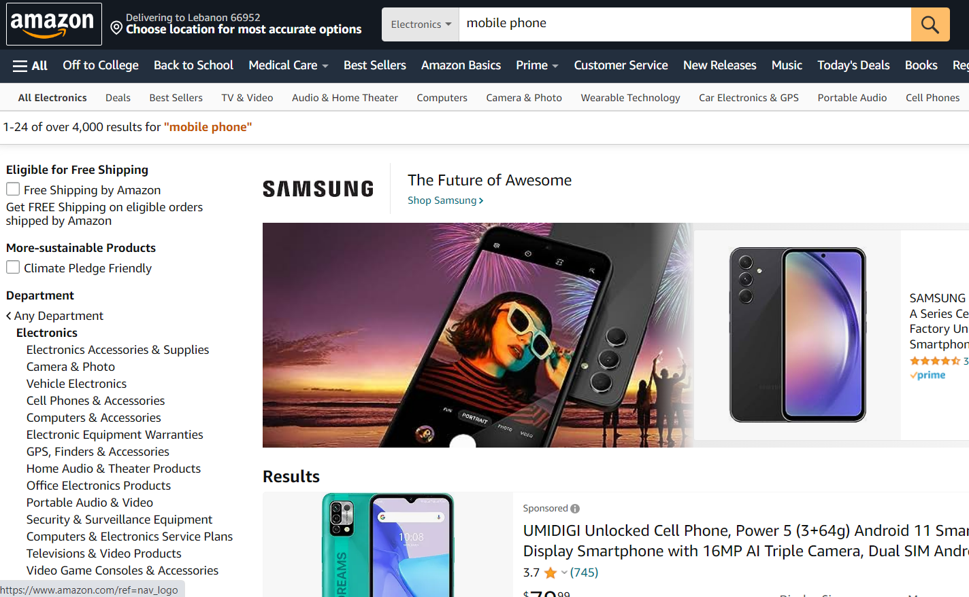

Link: <https://www.amazon.com/s?k=mobile+phone&i=electronics&crid=GZ8NCBH247Q3&sprefix=mobile+phone%2Celectronics%2C371&ref=nb_sb_ss_ts-doa-p_3_12>

**Example3:**

I have selected home appliances category. I have selected the items related to washing machines should be displayed.

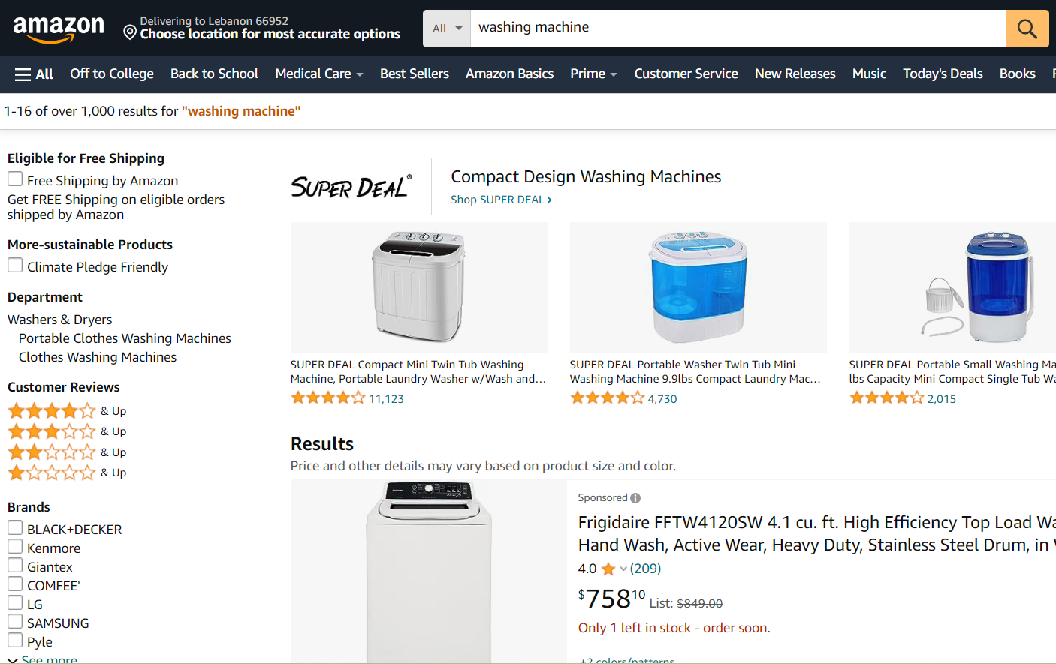

Link:

<https://www.amazon.com/s?k=washing+machine>

**Example4:**

I have selected the furniture category. I have selected the items related the wooden tables should be displayed.

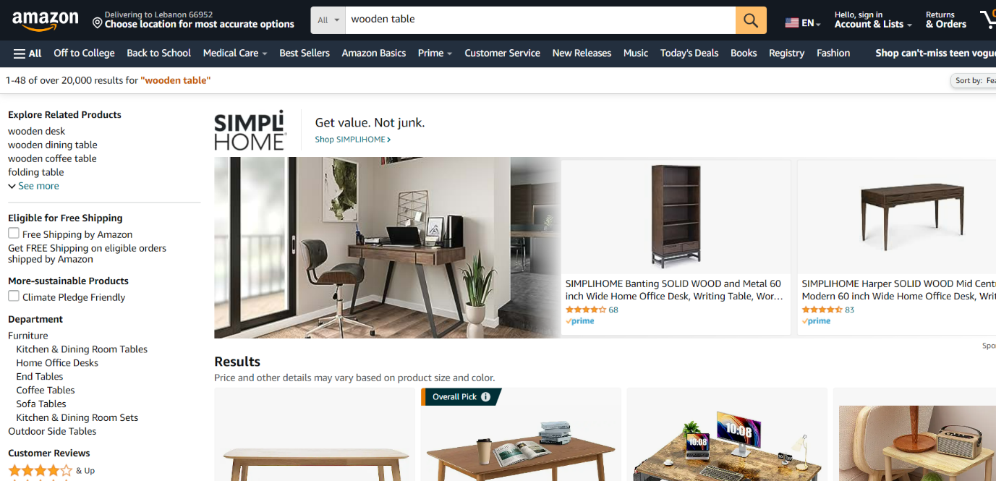

Link:

<https://www.amazon.com/s?k=wooden+table&crid=3H3PD4YM9Y0FW&sprefix=wooden+table%2Caps%2C326&ref=nb_sb_noss_>

**Convert Test Steps To Script:**

After developing the test cases, these test cases will be converted to test script with the help of recording modes. In Katalon we have three options to generate script

1. Record and play back mode
2. Manual mode
3. Script mode

Record And Play Back Mode:

* The term "Record and Playback" means that the recorded code is generated automatically and that this code is executed when the user selects to playback the recorded test scripts. Record and playback feature is a sort of automated testing in which a tool records and then imitates the user's actions.
* Regression testing is the best candidate to use record and playback for automation. Last but not least, record and playback testing is a great way to transition from manual to automated testing in your team. With test scripts created by the tool, you can get familiar with codes more quickly.

Manual Mode:

Manual testing handles complex test cases, while automated testing handles simpler, more repetitive tests. So, manual testing is still important. But adding automated testing makes your manual tests more efficient. Continuous testing is an evolution of test automation.

Manual testing is performed by testers who manually execute test cases and validate the software application against specified requirements. Here are some commonly used methods for performing manual testing: Functional testing: Functional testing involves verifying the application's functionality against the specified requirements

Script Mode:

When writing automation test scripts, consider some basic test design concepts that will help keep your tests simple and reusable. Try to write small tests that can be independently executed. Smaller tests make it easier to debug an application, since there are fewer possibilities for failure.

sample test case with the steps as written below: Firstly, open the browser. Secondly, navigate to a website. Thirdly, click on certain control. After that, validate if the control exists on the page. Finally, close the browser. Follow these steps to automate the above test scenario in the Script view.

Note: Recommended to use three different modes for different scenario’s.

TC_Amazon_Login_001:

WebUI.OpenBrowser('')

WebUI.navigateToUrl('https://www.amazon.com/')

WebUI.click(findTestObject('Object Repository/FaceBookPages/FaceBook_Login_OR/Page_Amazon.com. Spend less. Smile more/span_Sign in'))

WebUI.setText(findTestObject('Object Repository/FaceBookPages/FaceBook_Login_OR/Page_Amazon Sign-In/input_Email or mobile phone number_email'),

    'xxxxxxxxxx')

WebUI.click(findTestObject('Object Repository/FaceBookPages/FaceBook_Login_OR/Page_Amazon Sign-In/input_Enter your email or mobile phone numb_fc7402'))

WebUI.setEncryptedText(findTestObject('Object Repository/FaceBookPages/FaceBook_Login_OR/Page_Amazon Sign-In/input_Forgot your password_password'),

    '61KXoQNe1I2yVQJKbAvjIA==')

WebUI.click(findTestObject('Object Repository/FaceBookPages/FaceBook_Login_OR/Page_Amazon Sign-In/input_Enter your password_signInSubmit'))

WebUI.closeBrowser()

**Script/Test Case Execution:**

Execute both manual testing as well as automated testing for successful results. Choose a suitable automated tool for testing the application. Choose the correct test environment setup. Note down the execution status of each test case and note down the time taken by the system to complete the test cases.

The output of the execution of test cases is in the form of test reports, i.e., bug report or Test Execution status report. Teams can execute tests manually or by leveraging automation tools. The Test Execution tutorial section will look at some prerequisites for executing test cases.

Data -Driven Testing:

**Steps:**

1. Create/ take a test case (TC_Amazon_Login_001)
2. Create Data files (csv or xls) and add test data (TestData_Amazon_Login.xls)
3. Define variables and refer in test case
4. Add your data files to katalon studio
5. Create  folder under data file: folder name: Test Data under folder create test data   browse test data you created on desktop

Add test case to  Test suites (refer Activity 3.1)

1. Perform data binding with test data from excel

a. Click on show data binding

b. Once you click on show data binding, you get test data dialog box.

c. Under test data click on add so it will add test data file imported  data file.

d. Once it is added, perform variable binding

1. Save and run test cases.

**Activity 3.1: Adding test cases to test suite and test suite collection level:**

In this section, we are adding test cases to test suite and test suite collection level to perform execution scenario’s  for parallel and cross-browser testing.

This section has the following tasks:

* Add TC_Amazon_Login_001 to test suite level
* Perform Data binding
* Execute/Run  and observer expected value with actual value.

**Test suite:**

* Test suite is a collection of test cases
* Logical collection of test cases
* Test cases are grouped into categories

**Test suite collection:**

* It is a collection of test suits
* Why is it required
  + To group test suites logically
  + To run test  suites in sequence or in parallel
  + To run test suites on multiple browser environment.

**Handling And Validating Buttons:**

All tests, from unit tests to User Acceptance Tests, are Validation tests. Some of the standard tests under this heading: All validation tests ensure that a system works as planned by running all its functions and tracking tangible, quantifiable results. Any bugs missed during verification will be detected while running validation tests.

Handling And Validating Input Buttons:

We can input/give some text value by using the setText() method.

* Web UI. set Text (): is of three categories
* Web UI. set Encrypted Text ()
* If password is not encrypted, To encrypt the password

Goto help, encrypt text, give raw text

* Web UI. set Masked Text (find Test Object, null used when you have given date format as dd/mm/ yy in search text filled…than that format is displayed on search filled.

This section has the following tasks:

* For TC_Amazon_Login_001, validate the Username Input field
* Validate the login successful or not

First open amazon URL next click on Sign in/Login button. Then enter email or mobile number then click on continue button.

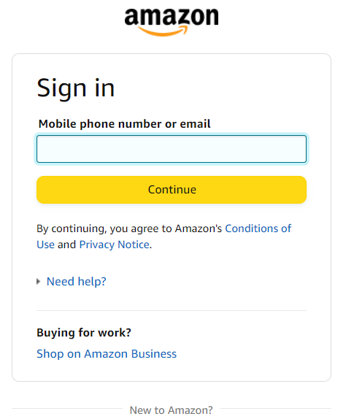

Next enter password then click on sign in button. the login was successfully completed.

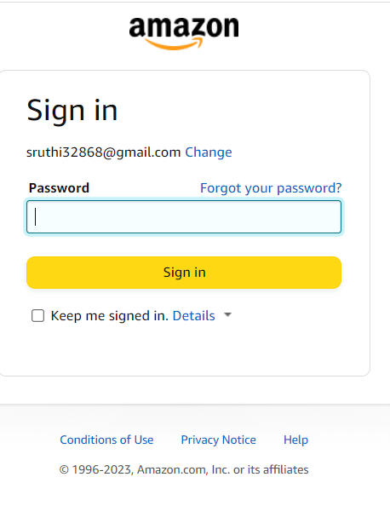

Link:

<https://www.amazon.com/ap/signinc>

Handling And Validating Dropdown Buttons:

The following options are available in katalon studio to select a combo box.

1. Select option by index
2. Select option by value
3. Select option by Label

Select Option By Index:

An Index option is a type of option where the underlying is an Index i.e. a basket of various selected stocks. The other type of options defined based on the underlying are Stock options.

Select Option By Value:

Each menu option is defined by an element nested inside the. Each element should have a value attribute containing the data value to submit to the server when that option is selected. If no value attribute is included, the value defaults to the text contained inside the element.

Select Option By Label:

The LABEL option displays labels on observations satisfying R STUDENT, LEVERAGE, and on the Cook’s D plot, COOKSD, where n is the number of observations used in fitting the model, and p is the number of parameters in the model.

This section has the following tasks:

* Generate Script for Make appointment: TC _Amazon _Validate Search Field Item _002
* Validate   "Category" dropdown button and verify if "Books" item available in the option or not.

Code:

WebUI.openBrowser('')

WebUI.navigateToUrl('')

WebUI.click(findTestObject(''))

unchecked = WebUI.verifyElementNotChecked(findTestObject(''),0)

if (unchecked == true) {

    System.out.println('element not checkeck')

    WebUI.check(findTestObject(''))

    System.out.println('element checkeck')

}

WebUI.delay(3)

WebUI.verifyElementChecked(findTestObject(''), 0)

Handling and validating checkbox buttons

* 1. Check()
  2. Uncheck()
* Katalon provides 4 methods to work on checkbox to check whether the checkbox is checked or noted

This section has the following tasks:

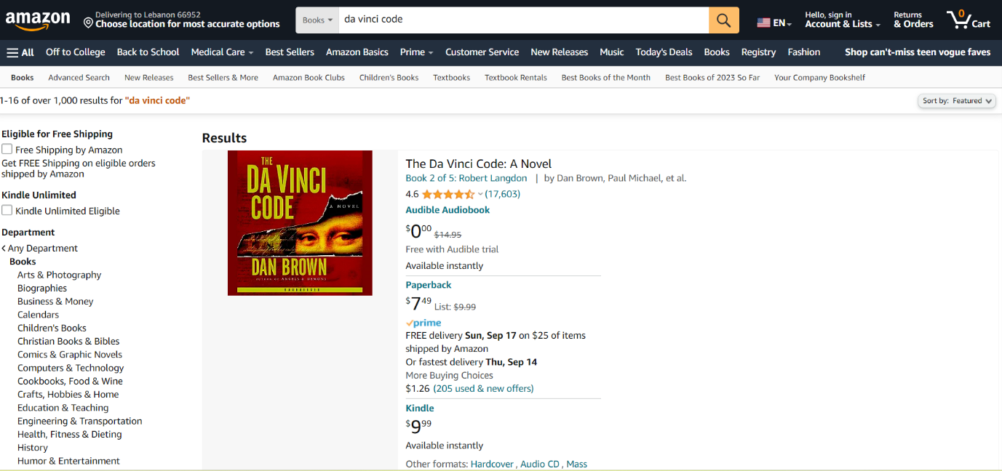

* Verify whether "Horror" checkbox option is disabled before you click on the checkbox
* perform click operation on the checkbox, and verify whether the test object is checked of or not
* If the Object is checked then uncheck the object, with un Check() method.

**Test Listeners:**

* We will optimize the flow of execution in such a way that frequently used test cases are annotated with @ Before Test Case, @AfterTestCase.
* Test listener is collection of annotation and classes
* Annotation are pre-defined class with certain functionalities and overridden methods
* Annotations acts as a meta data to specific method that control the behavior of the method
* Annotations are pre-fixed with @ symbol
* Before Test Case, After Test Case  and Before Test Suite, After Test Suite.

Setup And Tear Down:

**This section has the following tasks:**

* Add test case TC_Amazon_Login_001 to test suite level
* Add test case TC_Amazon_ValidateSearchFieldItem_002 to test suite level
* Under Test suite level, go to script mode
* Add Invoke Browser script under @setUp
* Add Close Browser script under @tearDown
* Run and observe the result.

Creating Test Listeners For Registration Validation:

**This section has the following tasks**

* Create test lister in Test listener folder: Amazon_ Validate Search Field Item _T Listener
* In Test Listener class, under @Before Test --> perform Invoke Browser actions and  under @After Test --> add Close Browser code
* Run the Test at test case level, test suite and test suite collection level.

**Note: All the other test cases you can run under test listener at test suite and test suite collection level.**

**Automation testing Amazon**

**Amazon Automation Testing Project**

**About Amazon:**

* Amazon is an American multinational technology company focusing on e-commerce, cloud computing, online advertising, digital streaming, and artificial intelligence web site for searching a product and order as per end user wish list. It has been often referred to as “one of the most influential economic and cultural forces in the world, and is often regarded as one of the world’s most valuable brands.
* It founded in 1994 by Jeff Bezos, amazon is one of the largest online retailers in the world, offering a range of products ranging from books and music to furniture and clothing. It also offers services like amazon prime, which offers unlimited streaming access to movies and tv shows, as well as free two-day shipping on millions of items.
* Amazon is the biggest online retailer in the world, stocking more than [353million products](https://www.retailtouchpoints.com/resources/how-many-products-does-amazon-carry) - not including books and other media. This means competition on the marketplace is stiff. To get ahead of other seller brands need to ensure their products rank in [Amazon's](https://www.channelsight.com/blog/amazon-a-content) search results. And one of the most effective ways to do this is with a carefully optimized Amazon product description.

## **The importance of Amazon product descriptions**

* Just [under half](https://www.emarketer.com/content/do-most-searchers-really-start-on-amazon) of consumers typically begin their online product searches on Amazon so putting resources into perfecting your Amazon product listings is essential - even if you employ an [omni channel eCommerce strategy](https://www.channelsight.com/blog/omni-channel-approach).
* Here are the two key reasons why product descriptions are so important.

### 1. They impact your visibility in Amazon's search results

* Your Amazon product description plays a central role in SEO. If you create a great product description Amazon's algorithm is likely to reward you with higher search rankings. With [a majority](https://www.webfx.com/blog/internet/amazon-search-result-infographic/) of shoppers never looking beyond the first page of Amazon's search results this makes product descriptions hugely important.

### 2. They enhance the customer experience

* A recent survey by   revealed that 87% of consumers believe product descriptions are very important or extremely important when buying something on Amazon. This means they have the potential to [increase your sales](https://www.channelsight.com/blog/4-ways-to-devise-a-winning-brand-strategy-on-amazon). By providing shoppers with all the information they need before placing an order you're also more likely to satisfy customers reduce returns and attract more positive [Amazon reviews](https://www.channelsight.com/blog/amazon-reviews).

**Table of Contents**

* Introduction
* Project Overview
* Getting Started
  + Prerequisites
  + Installation
  + Project Setup
* Project Structure
* Cross-browser testing using test cloud
* Report generation and sending report

Introduction:

The Amazon project is a Katalon automation project that utilizes the Selenium framework for automating web interactions. This documentation provides an overview of the project, instructions for installation and configuration, details about the project structure, and examples of test cases.

**Project Overview**

The Amazon project aims to automate various tasks on the Amazon website. It leverages Katalon studio, a powerful web automation tool, to interact with web elements and perform actions such as clicking buttons, filling forms, and extracting data.

Getting Started :

Explain the prerequisites and setup required to run the project.

**Activity 1:-Prerequisites**

Before getting started with the Amazon project, ensure you have the following prerequisites:

List the software and tools that need to be installed before running the project, such as:

* **Katalon Studio (Latest Version)**
* **Integration** **of Katalon Studio With Git And Github**
* **Integration With Jenkins**

**Activity 1:-Installation of katalon studio**

* To install the necessary dependencies for the Amazon automation project, follow these steps:
* **Activity 1.1:-** Install Katalon Studio: Visit the Katalon Studio website ([https://katalon.com/download](https://katalon.com/download%20) ) and download the latest version of Katalon Studio. Follow the installation instructions for your operating system.

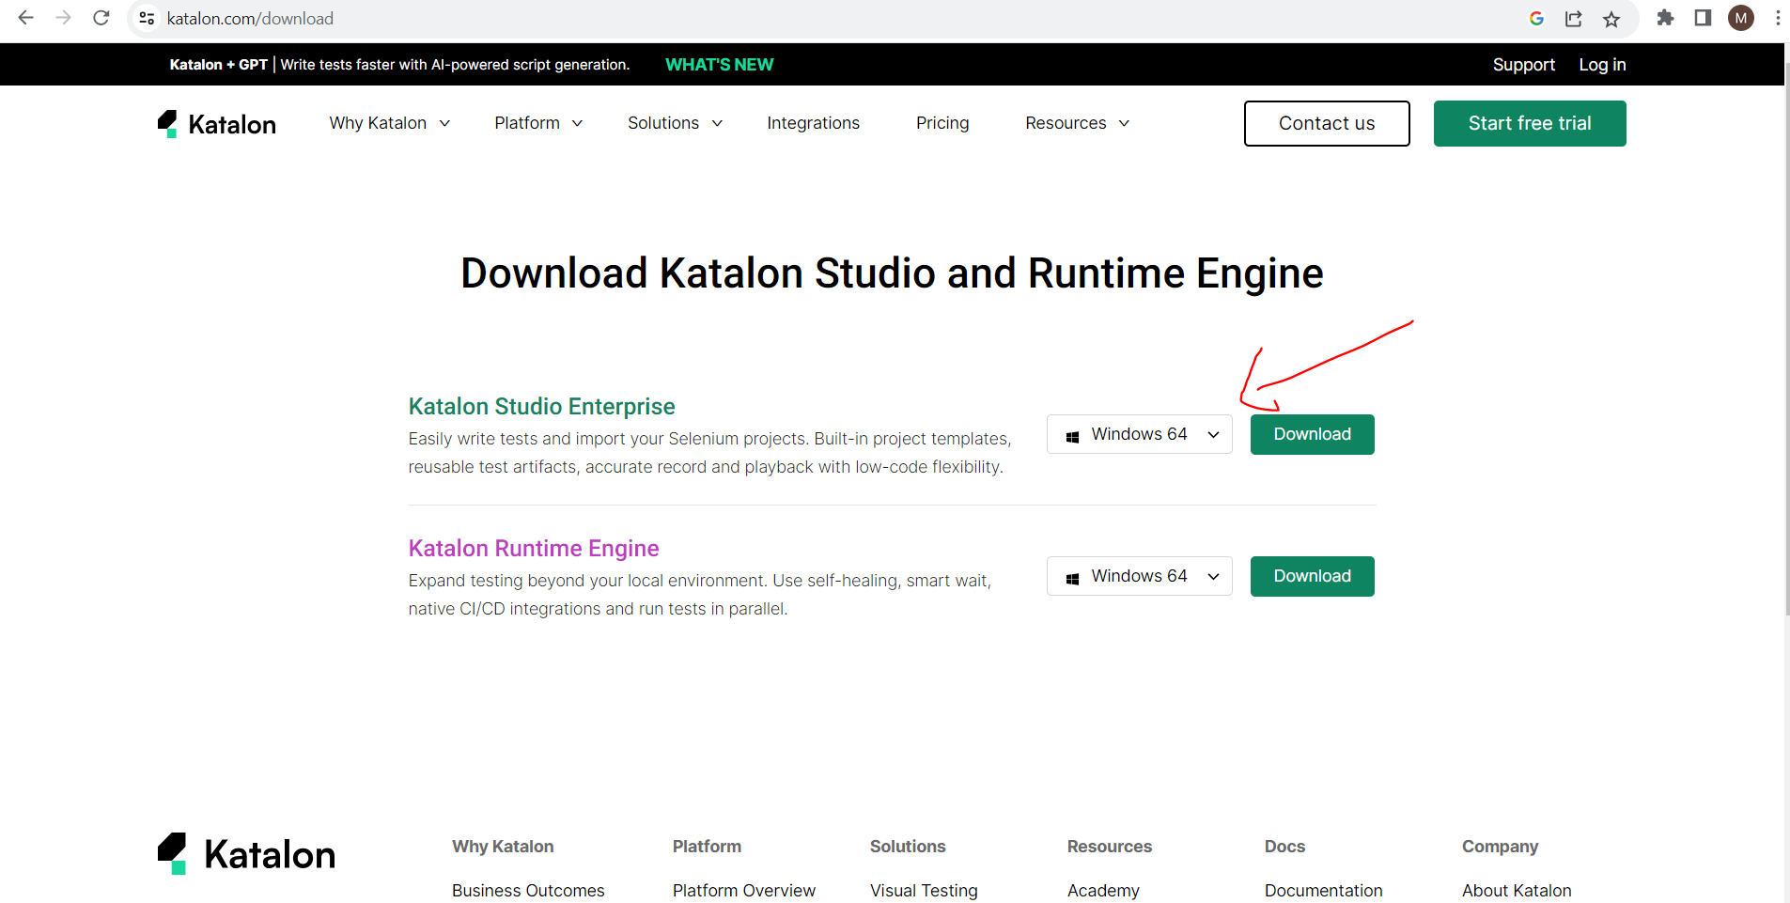

* After downloading Katalon Studio and extracting the contents from the zip file, locate the folder where you extracted it.
* In that folder, look for the "**katalon.exe**" file. This file is the executable for Katalon Studio.
* Double-click on the "**katalon.exe**" file to launch Katalon Studio. It may take a few moments to start up.
* Once **Katalon Studio** is launched, you can start creating or opening your project by selecting "File" from the menu bar and choosing either "**New Project**" or "Open Project" based on your requirements.

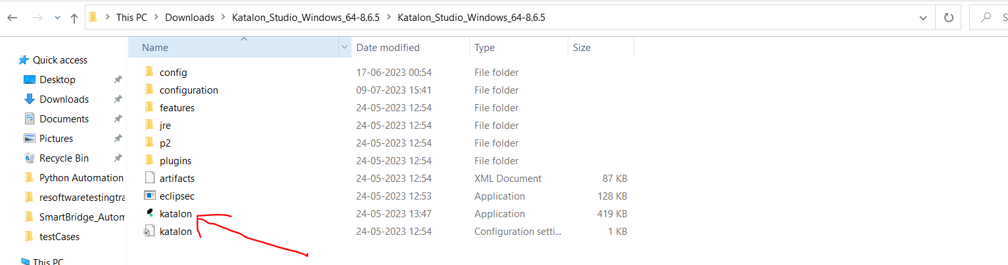

**Activity 2:-** Download and install **git hub** from https://git scm.com/download/win

**Integration Of Katalon Studio With Git And Git hub**

* This section has the following tasks :

* Go to google, and type git hub as below and click on the link

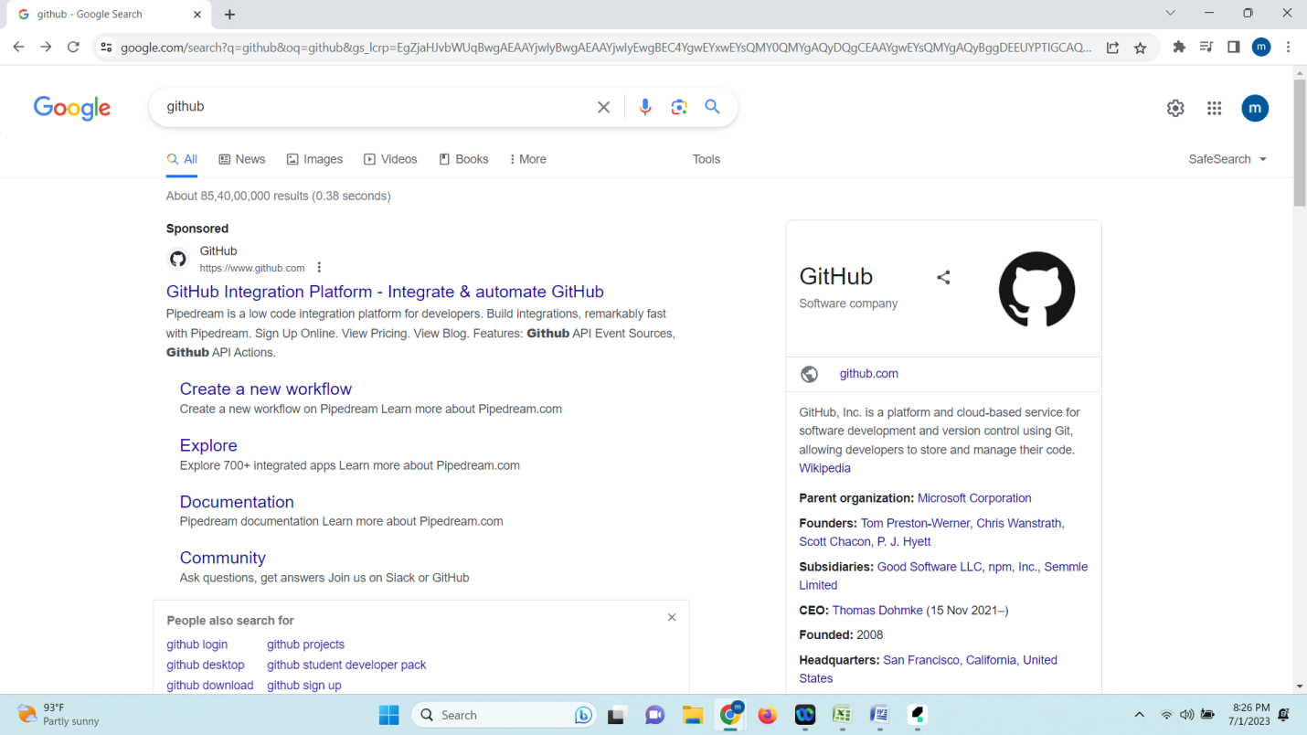

* When you click on link, your heading towards the official site
* Click on sign In, if you have account otherwise click on create new accout or sign up
* New account   signup

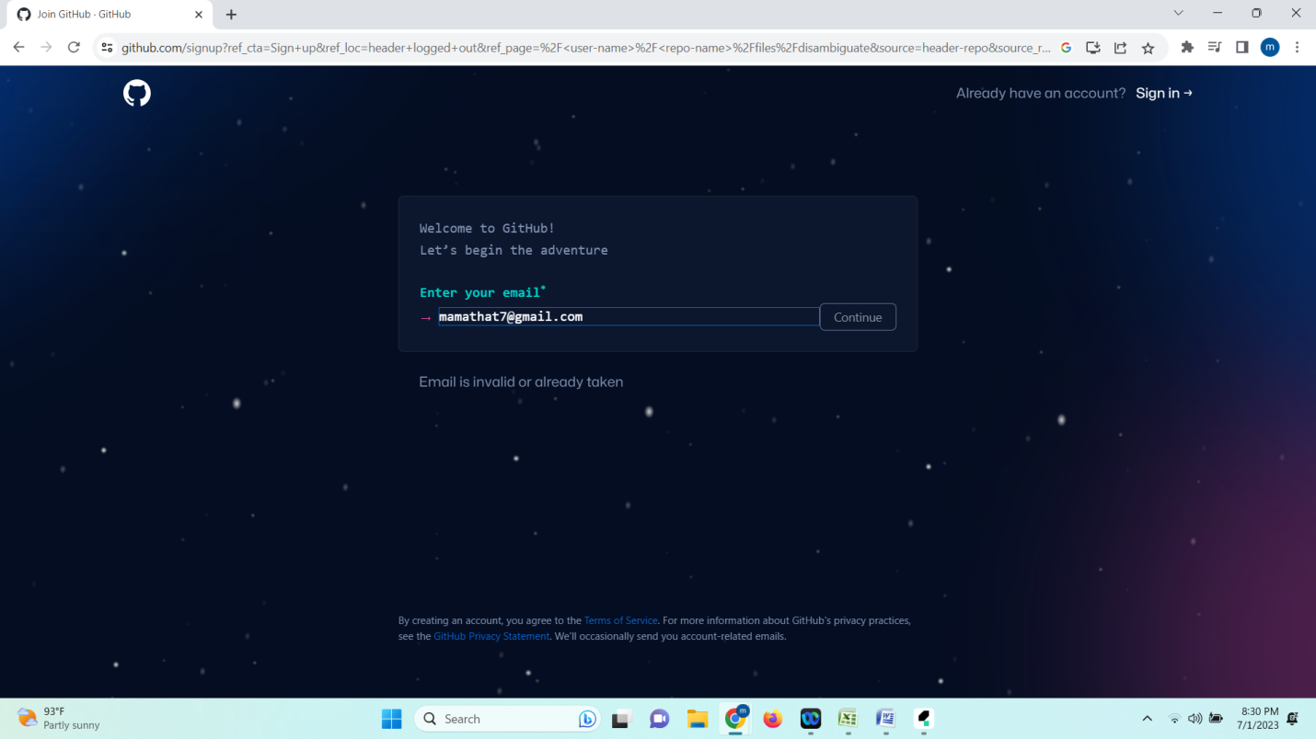

* Give your mail-ID and click on continue
* Give  your  new password and click on continue
* Enter username
* Creating a new repository on github: Click on (+) icon on top right corner

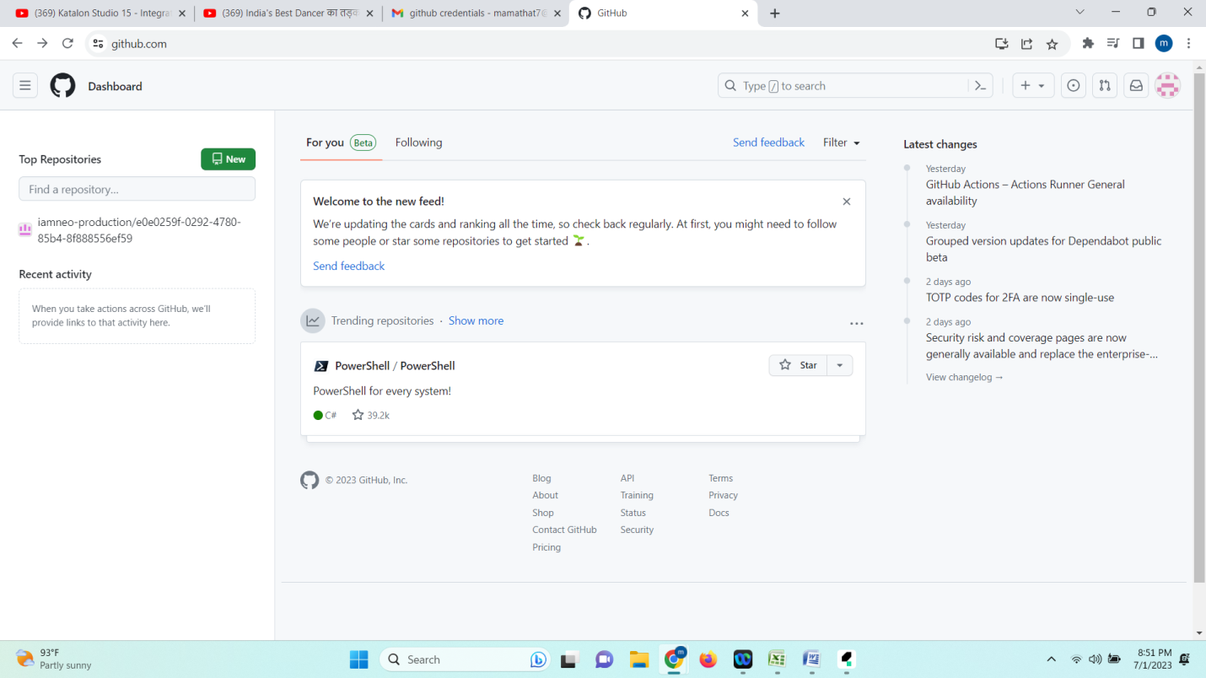

* Give Repository name: Katalon Git Test_ Integration
* Click on  add a README File, Initialize this repository

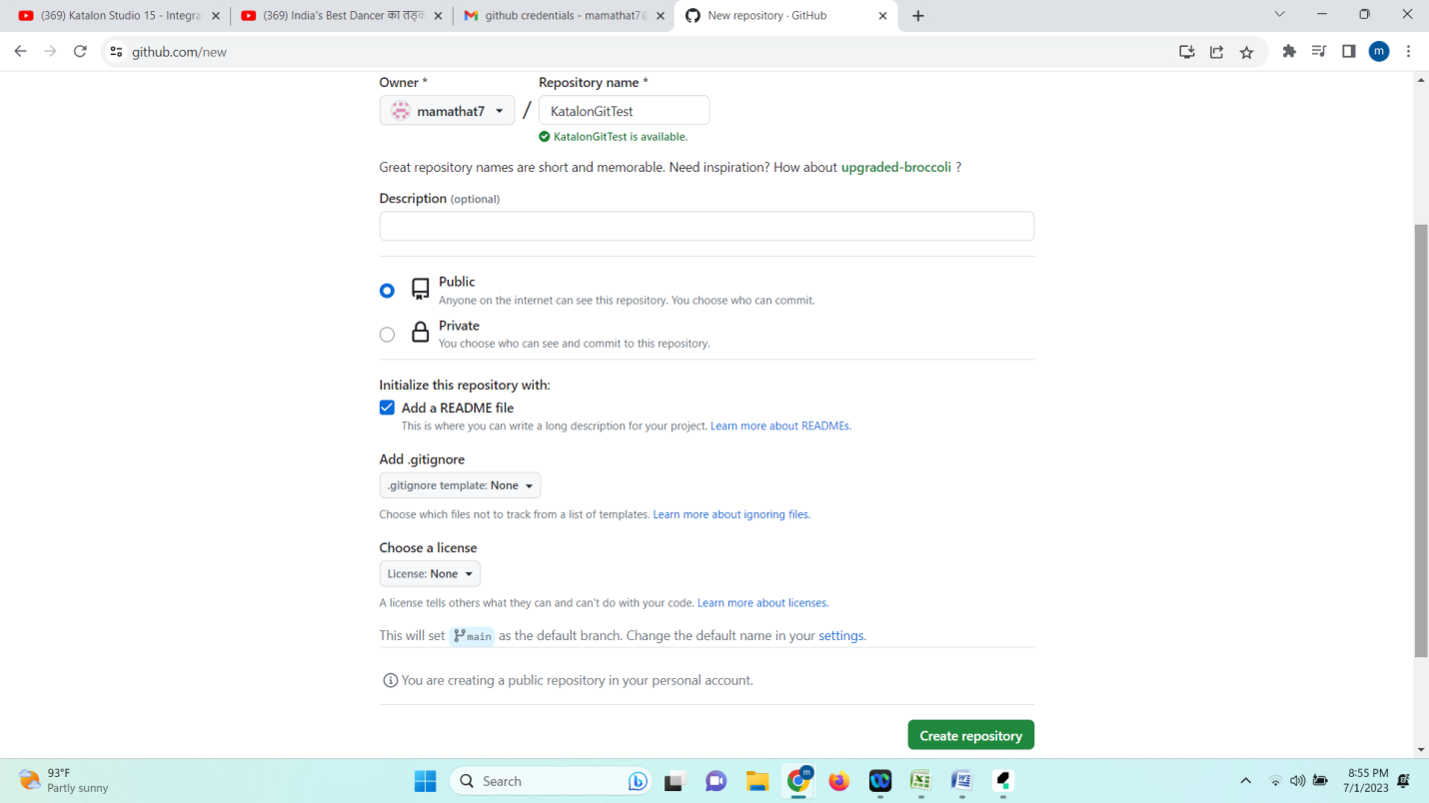

* Click on create repository

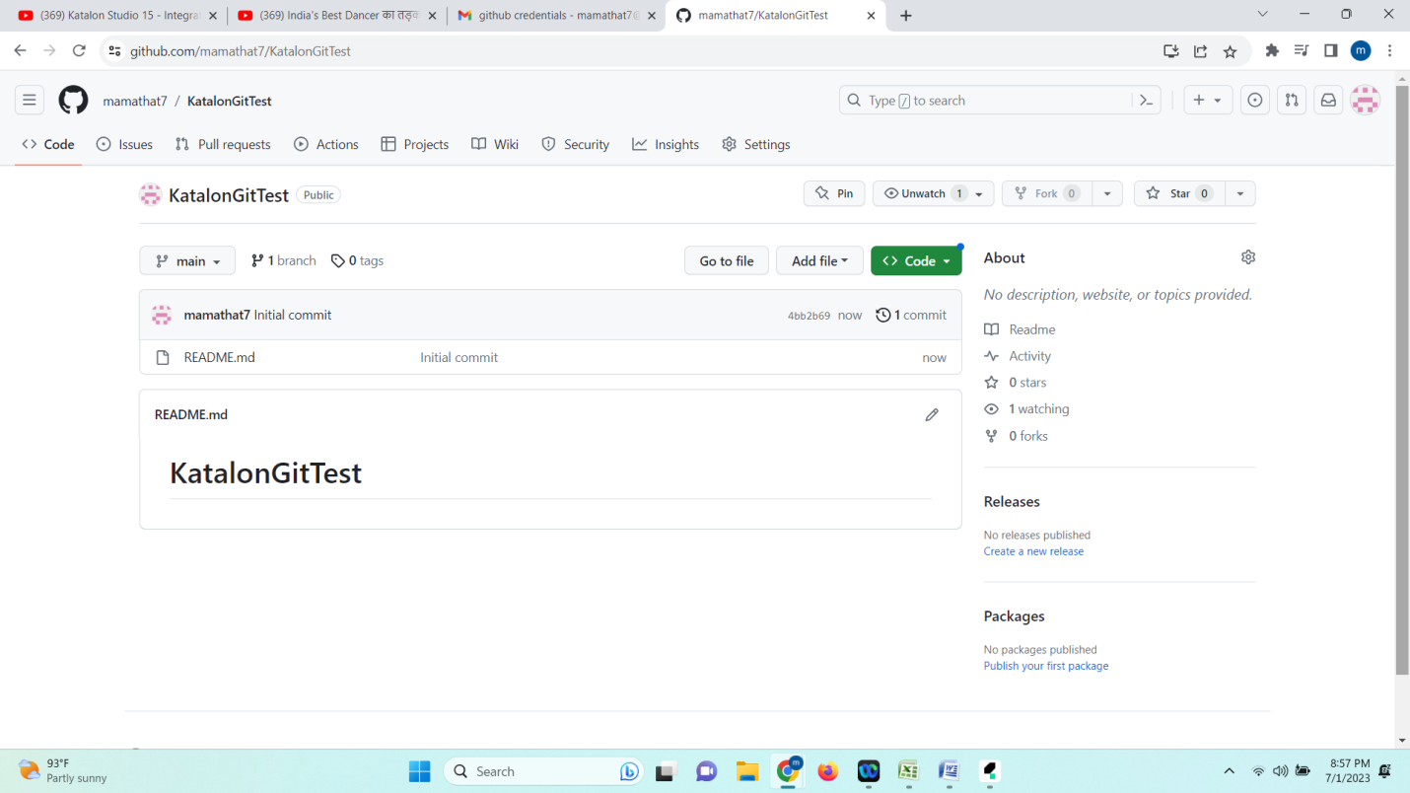

* In katalon studio create a new project
* click on git icon select clone project window appears as below

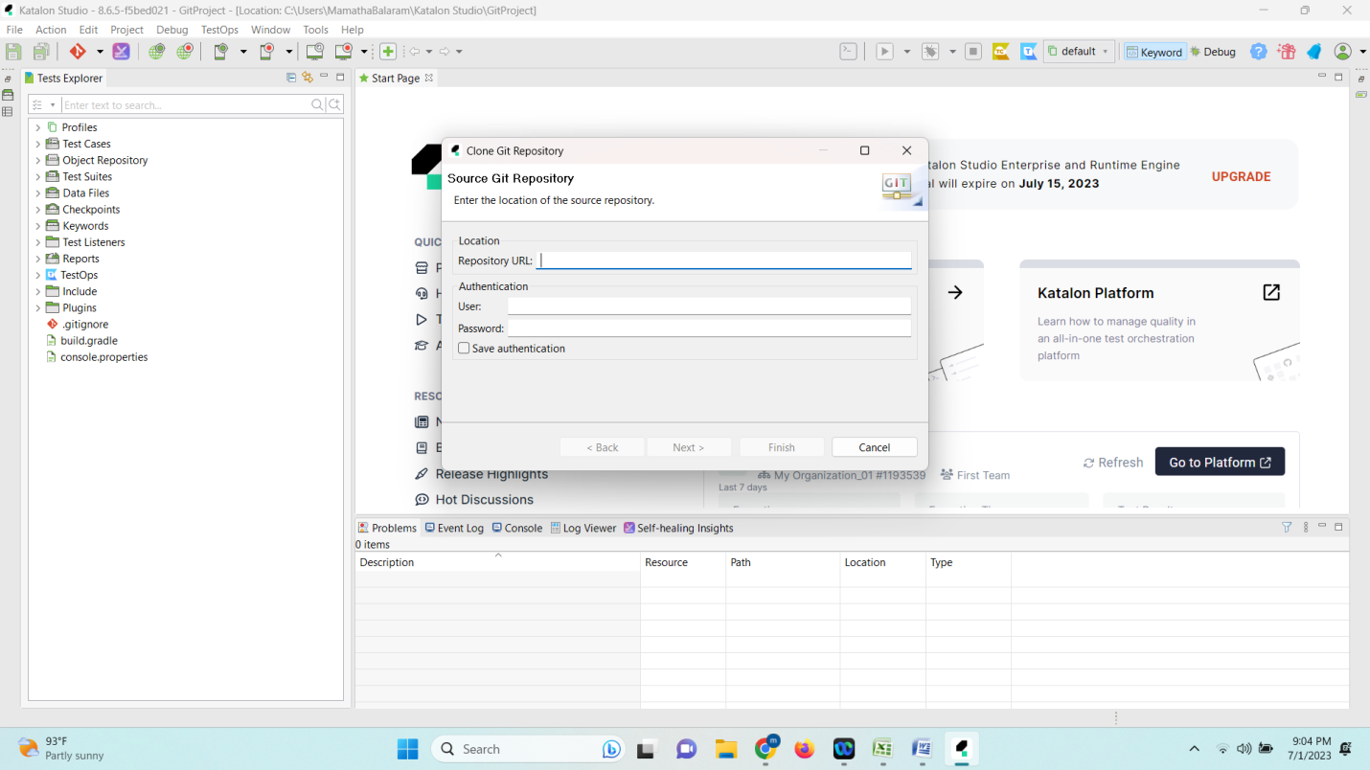

* Goto github, and click on code and copy the URL and paste in above

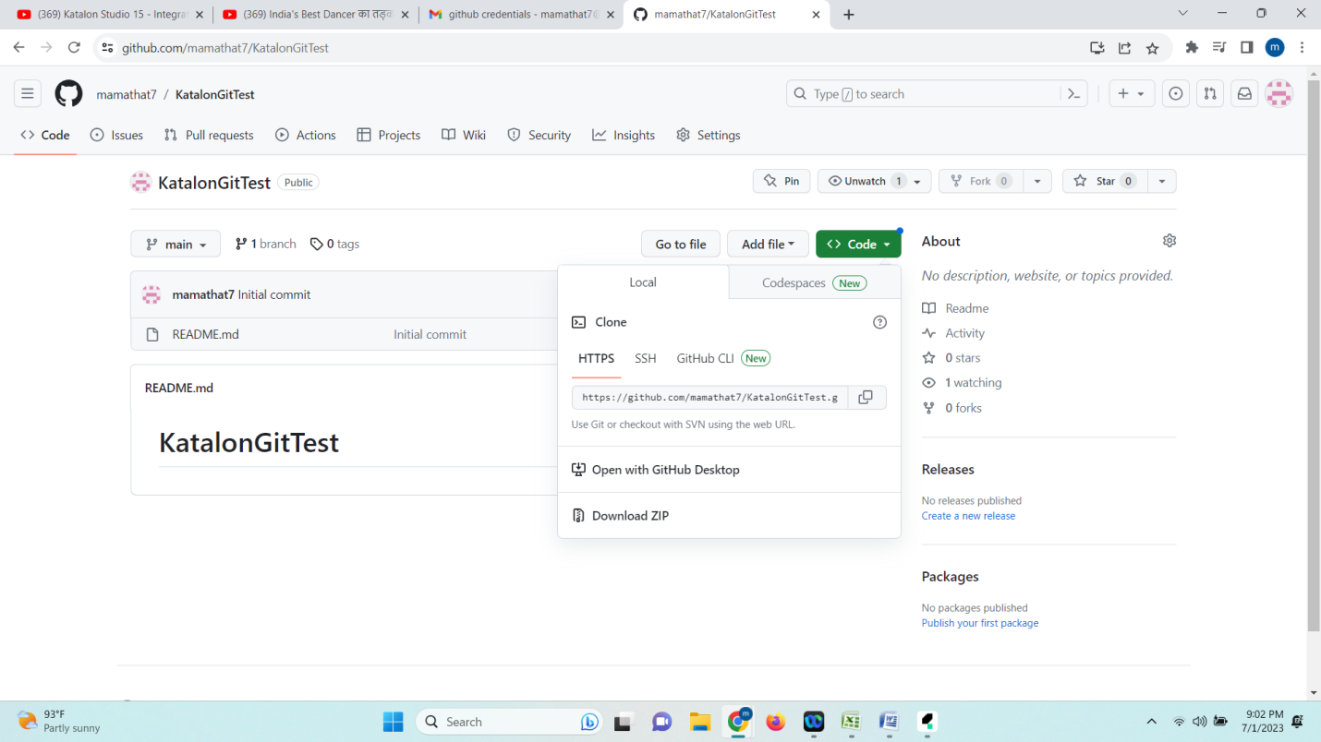

* Give url and user name and password as below

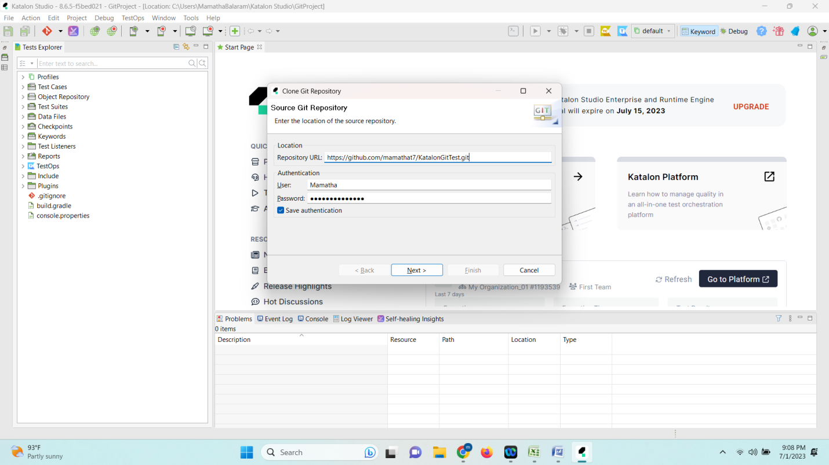

* Next

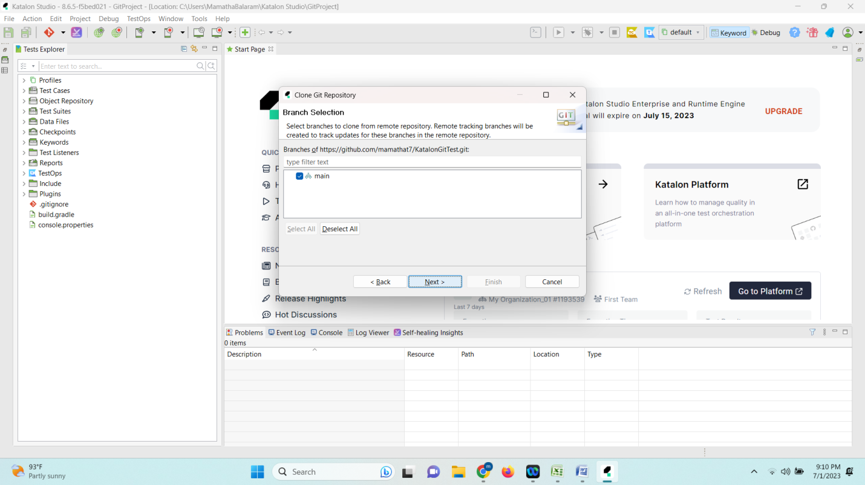

* Finish

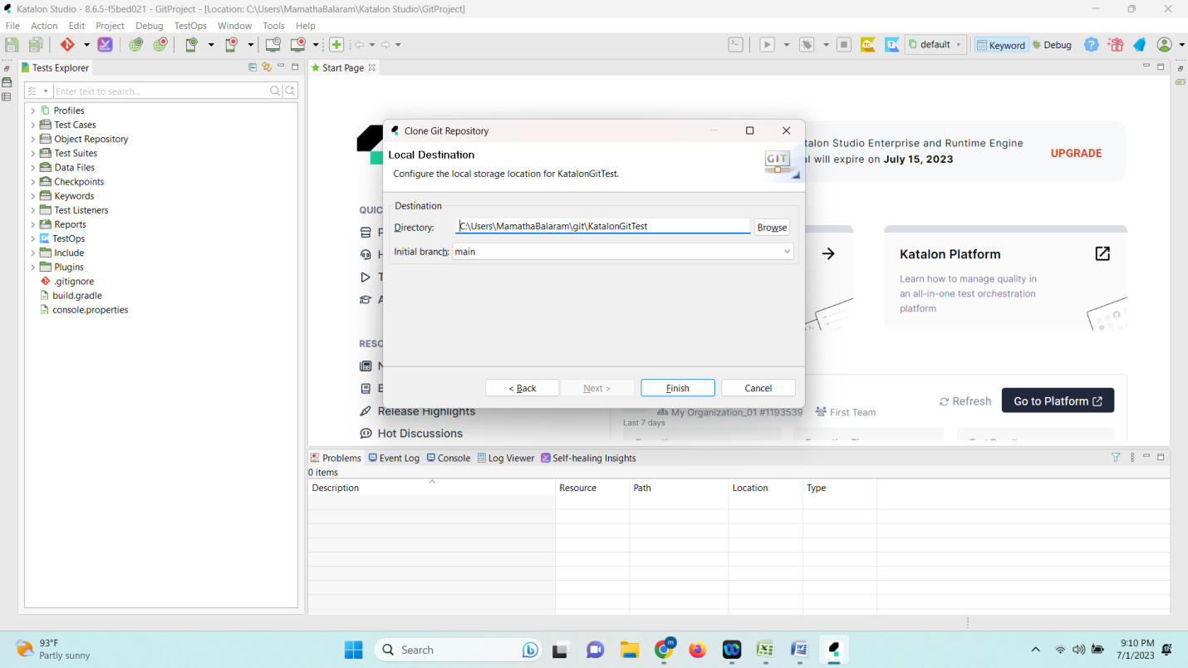

* If you see, your title of katalon location is changed to git location
* Now go to git hub you can see you have only one readme file is there so go to katalon studio select git click on commit

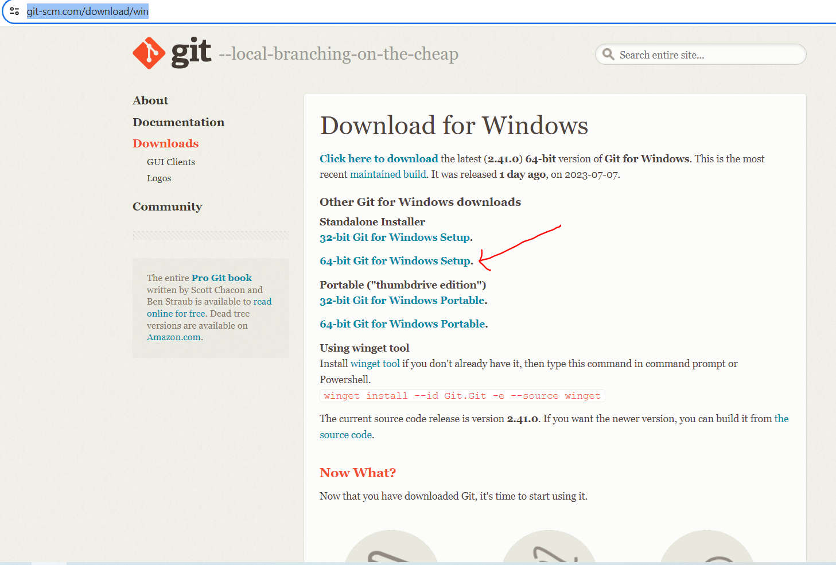

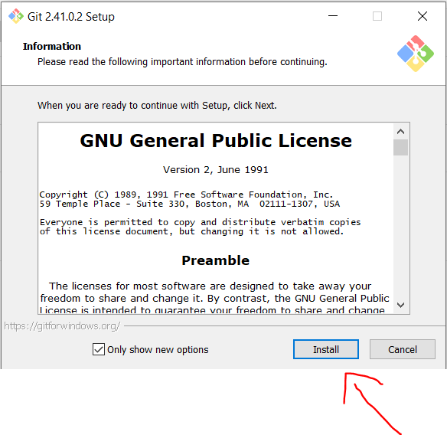

**Activity 2.1:-**

* Go to the desired location where you want to create the folder, such as Desktop.
* Folder name like eg…(Automation_Testing_Project)
* Open the folder-🡪 Right click with in the folder and select open gitbash here, you will get pop up like below and clone the repository based on the next steps provided below

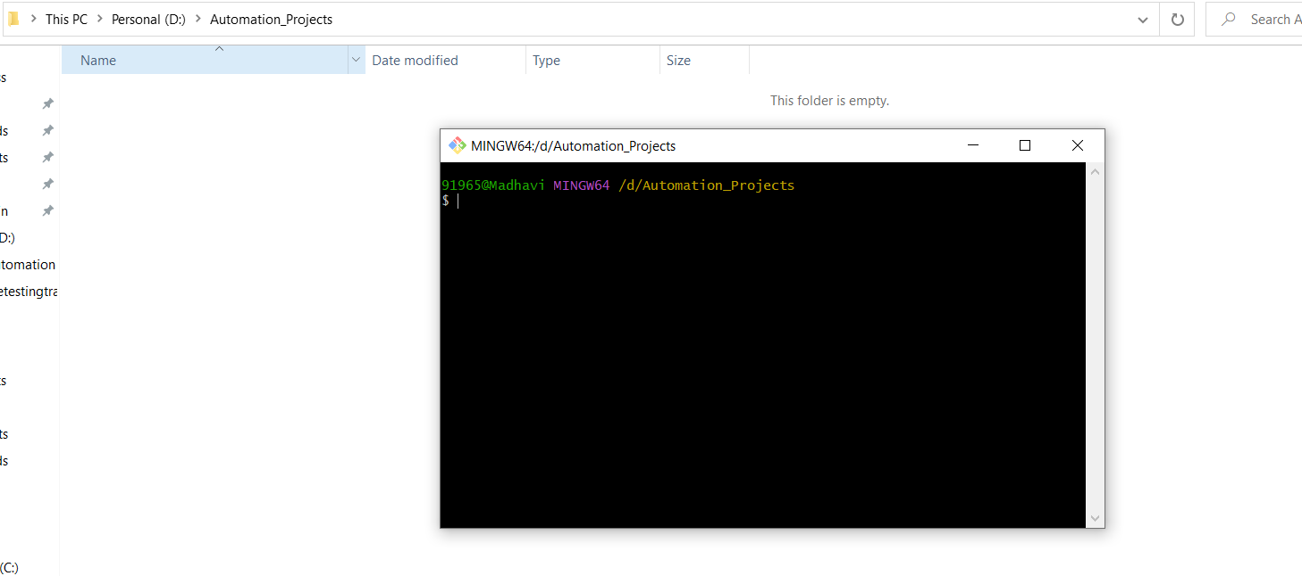

**Activity 2.2:- Project Setup**

* Explained how to set up the project locally, including steps like:
* Before cloning the project create project like below in Katalon Studio.

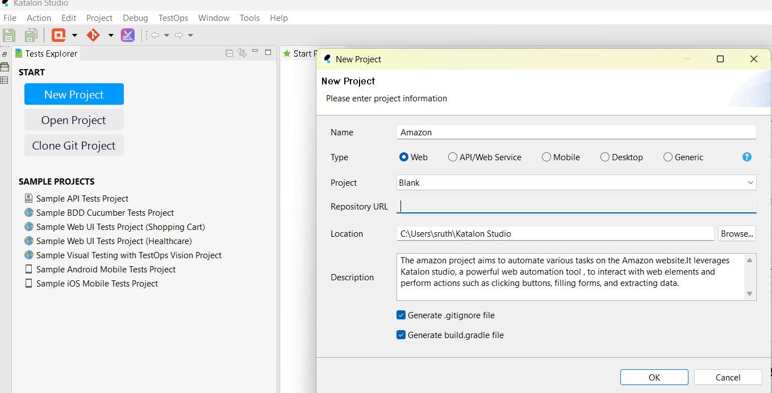

**Activity 2.3:-** Clone the repository from git hub.

**Activity2.4:-** Enter the repository URL and click ok. Repo URL provided below.

**Activity 2.5:-** Clone the Amazon project repository from [repository URL].

<https://github.com/sruthipachimala/AMAZON>

### Git Integration

--> version control system

--> source code management

**This section has the following tasks :**

* Enable git in your katalon studio
* if not enable
* window-->katalon studio preferences-->katalon--> git-->enable git
* github.com --->signup -->newuser
* github.com-->signin
* create a repository
  1. click on (+)
* In katalon create a new project
* Clone the project (git????clone project)
* git commit
* Goto github repository and refresh the page to see the project added

**Integration With Jenkins**:

**Activity 3**: **Installation**:-

* First download Jenkins .war file from Jenkins.io official site.( <https://www.jenkins.io/>)
* Then it shows in below fig in that click on manage Jenkins.

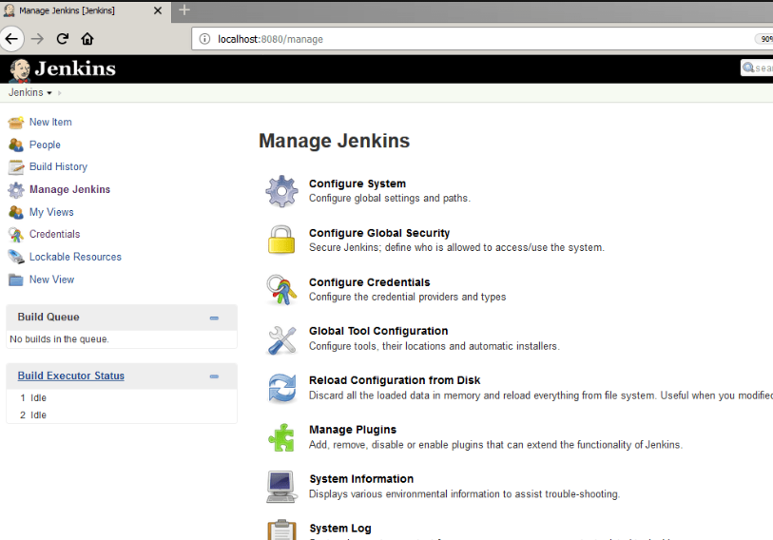

* Keep Jenkins. War file in specified folder like(c drive).

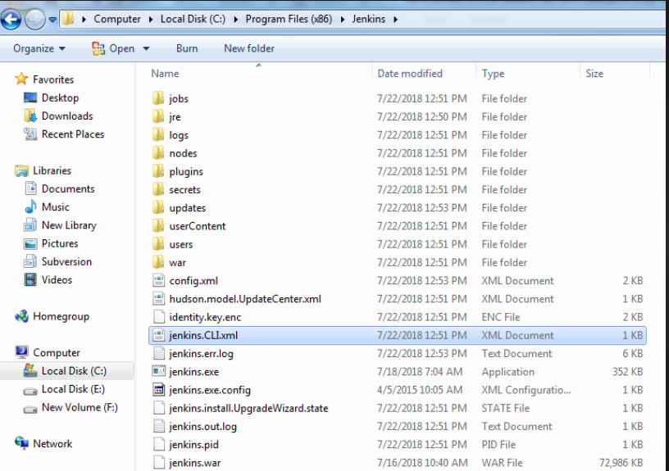

* Run java – jar Jenkins. War under Jenkins. War location.
* Copy the password store in notepad.
* Open the browser in address bar given by the host.
* Create Username &Password. For installation.
* Click on Save and continue button.

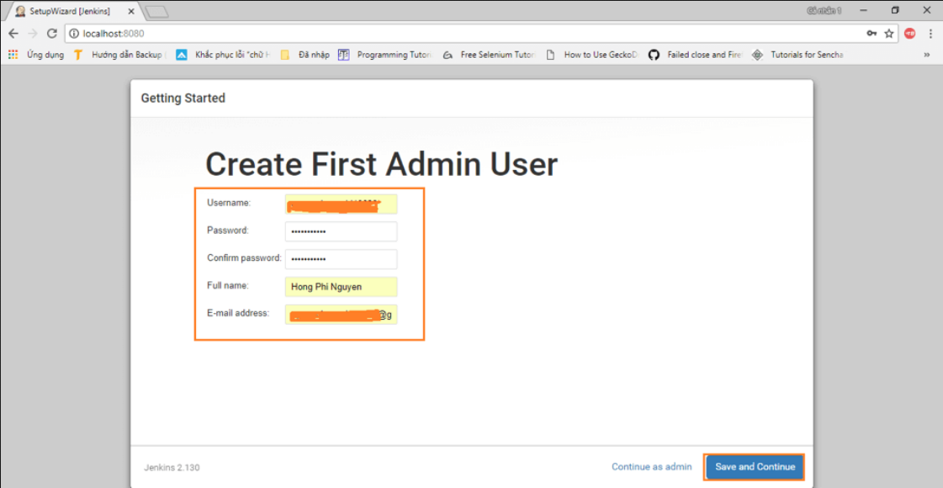

* Then click on install and give access to windows security.

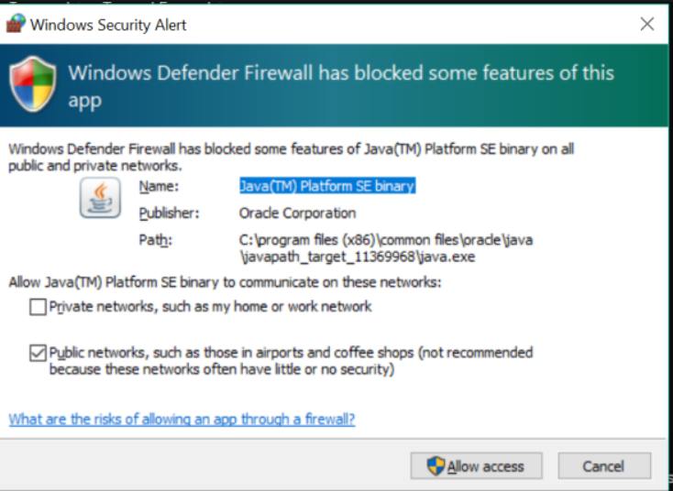

* After allow access. It goes to Jenkins setup.
* Then click on next button.

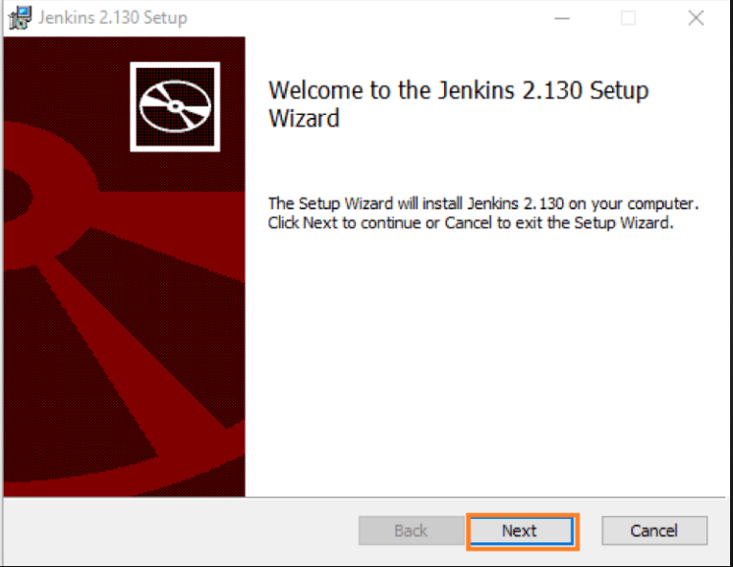

* This Jenkins, git hub, and katalon are used for testing the testcase through scripts and manual test suits.

**Activity 3.1: Integration of Jenkins with katalon:**

* Jenkins should be downloaded--> extract to specified folder (C:)
* Jenkins installation and setup
* Download and activate katalon runtime engine (KRE)
* --> used for scheduling test
* --> integrating with CI/CD
* -->Execute your tests with distributed server
* katalon studio integration with jenkin
* create a sample test case --> add in test suit --> add in test suite collection
* Execute command line generated for test suite/ test suite collection from katalon studio in Jenkins
* At test suite level, click on Build CMD icon  to generate command, copy the command and close dialog box
* In command line, go to the location of our KRE
* paste the generated command at KRE location
* Run the test.

### Integration With Katalon Git, Github And Jenkins

* Open Jenkins/start Jenkins
* Click on manage Jenkins plugins installed git plugin (check whether git plugin available or not)
* Manage Jenkins tool git path to git execution: c:\programfiles\git\
* Click on apply  and save button
* Create a project in jenkins (refer activity 3)
* In General Description select: Git hub Project
* Goto source code management, select git option

Add URL (from git hub  clone and download)

Add credentials

Specify branch: main/master

* Goto Build Trigger

schedule your execution under poll SCM

* Goto Build

Under Build select: Execute under window command line

* Goto katalon studio test suite level click on Build CMD generate command copy and close
* Open a note pad, copy the command to notepad and other corresponding commands as below:

**cd "c:\Users\sruthipachimala\git\SamplegitIntegration\SamplegitIntegration"**

**git pull "https://github.com/sruthipachimala/demosample.git "**

**cd "C:\katalonRuntimeEngine\Katalon_Studio_Engine_Windows_64-8.6.5 "**

**katalonc -noSplash -runMode=console -projectPath="C:\Users\sruthipachimala**

**\Katalon Studio\KatalonAutomationTesting\KatalonAutomationTesting.prj" -retry=0 -testSuitePath="Test Suites/Jenkin_testsuite_sample" -browserType="Chrome" -executionProfile="default" -apiKey="0d717ad6-0eab-4dbb-b878-969cf75a8c10" --config -proxy.auth.option=NO_PROXY -proxy.system.option=NO_PROXY -proxy.system.applyToDesiredCapabilities=true**

**cd "c:\Users\sruthipachimala\git\SamplegitIntegration\SamplegitIntegration"**

**git status**

**git add *.\***

**git commit -m "change for test on jenkins"**

**git push -u "https://github.com/sruthipachimala/demosample.git" main**

**echo Sucess**

* Run
* Observe report generated under Report folder.

**Project Structure:**

**Activity1:-** The structure of the project, including directories and files, and their purposes. For example:

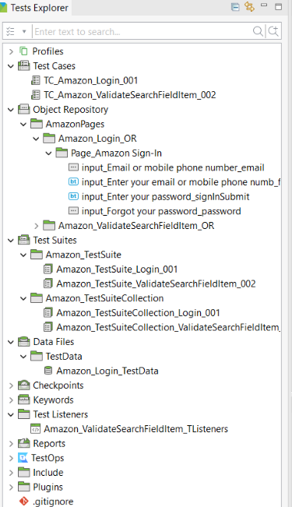

* **Tests cases/**: Directory containing test scripts
* **Object Repository/**: Directory containing page object models
* **Test Suites/**: Directory containing run multiple test cases
* **Test Listeners/**: The events in a script and modify test cases
* **Datafiles/**: Directory containing test data (**ex: excel, csv, text, json files**) related to project
* **Run: Option to run all the testcases from the top quick access tool bar.**

**Cross-Browser Testing Using Test Cloud**

### This task used when your organization not having enough resources to perform manually, katalon test_cloud automate test scripts across the most popular browsers in different environments.

* This section has the following tasks:
* Take TC_CURA_MakeApointment_002
* Integrate katalon studio with test cloud

projects-->settings--> katalon test cloud

                      (or)

Simply click on Tool bar icon

* select testcase at Test suite level
* Run -->test cloud

### Report Generation And Sending Report To Developers

* The final step of the katalon step process is to generate report and analyse the report .
* Quality of the product by discussing with different stakeholders in the project under testing for next actions and eventually whether or not ready for the market release.

Activity 1: Send report through email

* Goto project settings email fill all required fields apply and save close

Activity 2:  Test Email Notification

Goto test suite Open execution information mail recipients add emails ok.

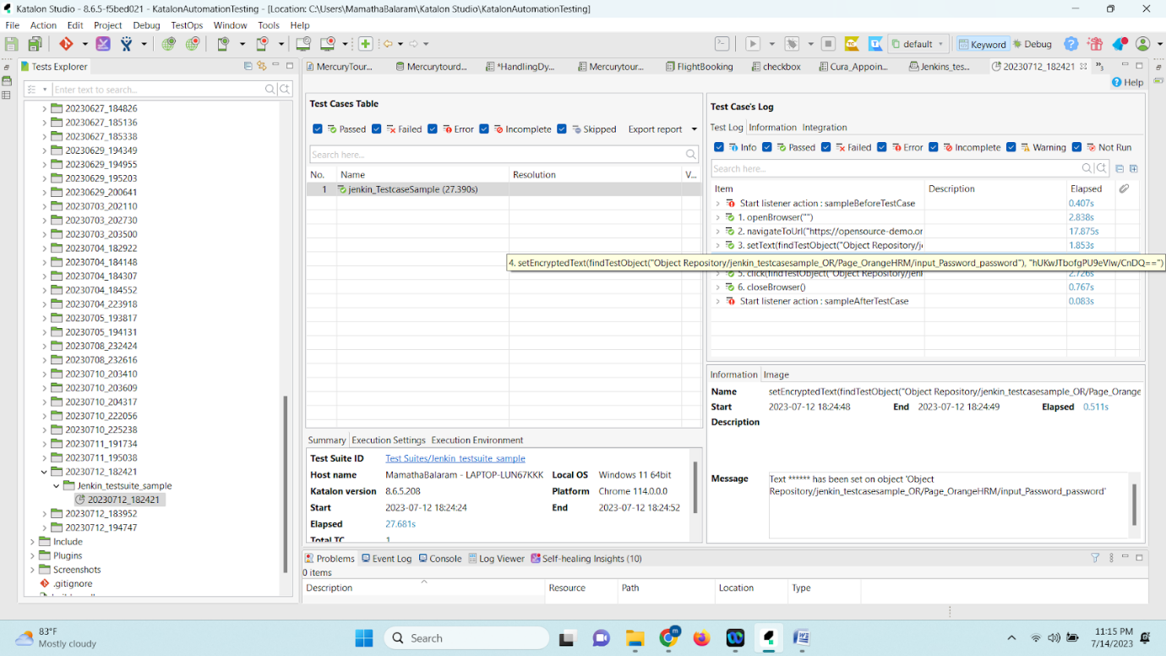

Thank you!